www.WomenAndMathMentoring.org

We wish to thank the following persons
and organizations for their continued support of
The Women and Math Mentoring Program

NC Central University Department of Mathematics & Computer Science
NC Women & Mathematics Network
Mr. Grayling Williams, Durham Public Schools
Blue Mountain Expressions

And of course, our Corporate Sponsors
GlaxoSmithKline
Durham Merchants Association Charitable Foundation
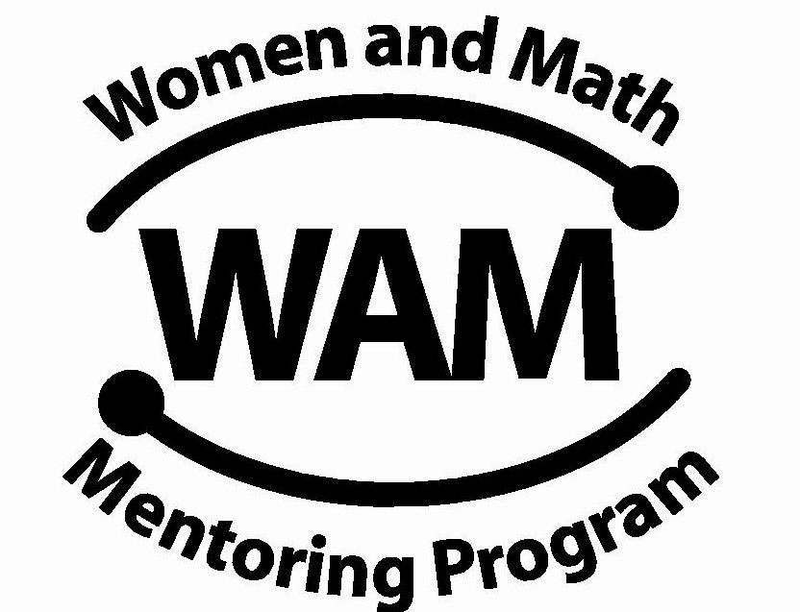

NC Women & Mathematics Network

MENTOR
ORIENTATION
PROGRAM
November 19, 2011

North Carolina Central University
College of Science and Technology
Mary M. Townes Science Building

November 19, 2011

Agenda

- 9:00-9:30 New Mentor Registration
Room 2229 & Breakfast

9:30-10:00 New Mentors Orientation
Room 2221 Welcome to WAM!
Tina Ewing
What is an 8th Grade Girl?
8th Grade Curriculum
Melissa Hancock

- 9:30-10:00 Returning Mentors Registration Room 2229 & Breakfast

- 10:00-10:15 Field Trips and Projects
Room 2221 Victoria Thio

- 10:15-10:25 Marjorie Lee Browne Career Day
Room 2221 NCCU Students

- 10:25-10:30 Summer Scholarships
Room 2221 Vermelle Wilson

- 10:30-11:30 Next Steps
Room 2221 Mentor Team Break-Out Session
Dr. Laura Smith
Sessions with Mentor Leaders
Sally Medling
Q&A-Tina Ewing

